**WORKSHOP 1 – Therapeutic Approaches to Composition**

1. Name game

[Name Game.mp4](https://drive.google.com/file/d/1XP6YUkM1P7zTG9dgwNtdznV9RRe6BGSI/view?usp=sharing)

1. Create ostinati with words & body percussion

* Say phrases as loops
* Add body percussion
* Remove the words

1. My name’s Jennifer, I like Biscuits, - walk it round the room saying to a steady pulse - My name’s ____ and I like ____ - shaking hands with people
2. Swap the beats around

Ostinato 1 - My name’s Jennifer and I like biscuits

Ostinato 2 - Biscuits My name’s Jennifer I like

Ostinato 3 - Jennifer I like biscuits my name’s

1. Voice and body grooves using phrases Favourite character from a book - Dumbledore….sabaurs snape” - work in 4s, add percussion, swap 4 in groupings. Taking turn over ostinati - how can we structure 4 people playing? Can you add beatboxing? Can you
2. Use longer combinations

BEATBOXING

https://www.youtube.com/watch?v=Kv4g4AEH_po&ab_channel=JimmyRotheram

STORYTELLING

Little Bunnies Sleeping - improvise your own story with musical sound effects

## 

## Tell Stories with Musical Responses

#### Little Bunnies Sleeping

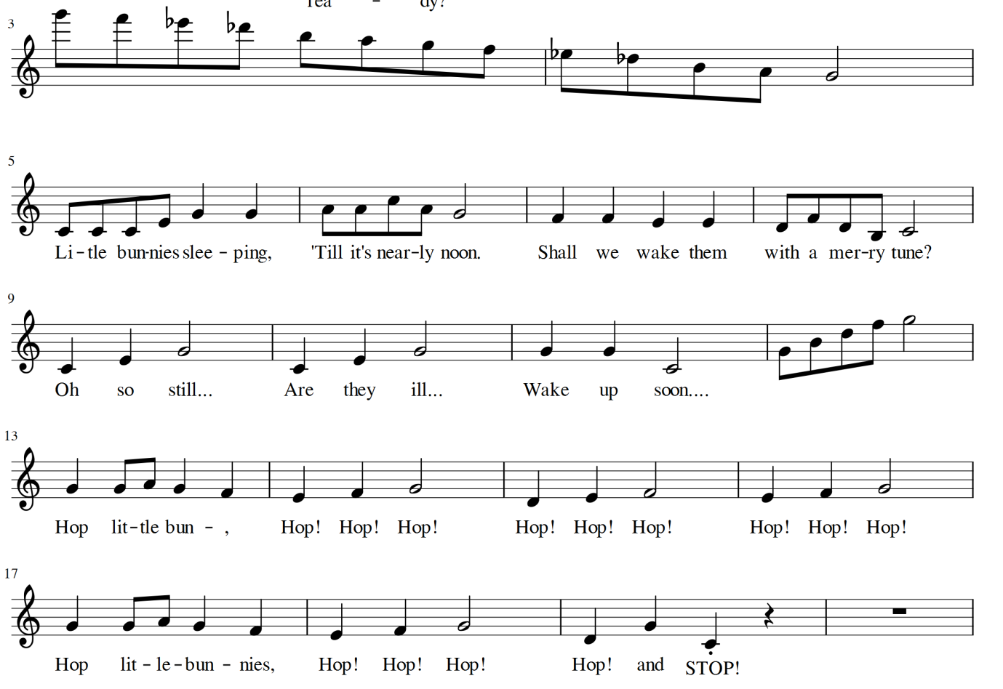

Children simply “sleep” for the first half of the song and then leap around. Under 5s can jump on the “hop little bunnies” bit, but 5 year olds should be at a stage where they can hop without falling over too much!

A lovely little take on this from Feversham - whilst children are in the sleeping part of the game, make sure all children have their eyes closed, and then blow lots of bubbles up into the air - when the children get up again, they will be pleasantly surprised to find lots of bubbles in the air and to hear you singing in a genter voice, “pop all the bubbles, pop, pop pop….”

This a great early game for classroom management. Playing or singing the "little bunnies scale" - (for the musicians amongst you, it’s an ascending and descending whole tone scale) will immediately cause children to yawn, stretch upwards and then and lie down silently. Don’t worry if you can’t play an instrument - all you have to do to get children to lie down is something that goes from high to low in pitch - a swanee whistle, run your hand down a piano or drag a stick down a glockenspiel (going from high to low pitch in this way is called a glissando).

You can finish the song here if you want, or go to the lively section to gee them up. You will have a mixture of shyer children seeking peace and quiet and lively expressive children. This song is inclusive of all of them and children love the contrast. This tension and release is something that you can play with - leave them sleeping for just a bit longer, or get them excited and hopping unexpectedly early

The extended game below can last for around 20 minutes and prepares many concepts unconsciously, as well as storytelling, so it is a great one to do often.

## Accompany Stories on an Instrument

If you want to join in with an instrument, you don’t need to be able to play it!

"Then the bunnies got dressed. they pulled their trousers up" . As you say this

"And pulled their shirts over their head" (when we draw our hand down a piano to play every white note quickly,or scrape a glockenspiel from right to left, it is called a glissando. Give it a try. You have a great musical sound effect. )

"What else did they do to get ready?" - (whatever the children suggest, do it to a steady pulse. When they suggest cleaning teeth, do a low trill for cleaning their bottom teeth and a high trill for cleaning their top teeth" (a trill is two notes next to each other, played as quickly as you can.

"Then the bunnies hopped down the path" - (Repeat the word “hop” and encourage children to hop only when you shout "hop" to a pulse and stop when you say "..... and STOP").

"They came to a river with......1.....2....3.....4.....5 big stones!. They jumped onto the first stone (small glissando) They jumped onto the second stone (slightly larger glissando) They jumped onto the third stone (bigger glissando) They jumped onto the fourth stone (bigger glissando) They jumped onto the fifth stone, but it was really far away....... (large glissando)....and the bunnies all fell down (hit random clusters of notes)

"They pulled themselves back up again (glissando up). But they were all muddy, so they gave their bodies a little shake (tremolo). And they were still muddy so they gave themselves a bigger shake (tremolo) And they were still muddy so they gave themselves the biggest shake they possibly could (loud tremolo). Then the bunnies were nice and clean so they hopped down the path again......Hop Hop hop!"

Then the bunnies came to a big door with a high doorbell (say in high voice) and a low doorbell (say in a low voice).They rang the high doorbell (ring "so" bell or chime bar). They rang the low doorbell (ring "mi" doorbell). And the door was answered by......

1) Mr Tickly Monkey - who chases the children around the class.

2) The Wizard - dress a child up as "The Wizard" - they then have the power to turn the bunnies into different animals

3) What other characters could answer the door to the children?

"After all of their adventures, the bunnies were very tired." (play sleeping bunnies scale) and ready for bed (children go to sleep).

"And as the bunnies slept, they had a very strange dream. They dreamed that they were no longer little bunnies but little children at ___________ school. Instead of big bunny rabbit ears, they had little childrens' ears. And instead of big bunny teeth.....they had little children's teeth (some of them even had missing teeth!) And instead of brown, furry bodies, they were wearing (describe the school uniform)"

"And when the bunnies awoke, a strange and wonderful thing had happened (glissando up). The bunnies had turned into little children. Hello children!"

The plot is not going to win a Booker prize any time soon, but the point is merely a narrative on which to hang lots of musical experiences and skills. This can also be a great way to structure your lessons and activities, turning each small activity into a nicely woven narrative to spark the imagination

## Create Your Own Stories from Songs

Once you have told a few stories like this, making your own becomes easy - pinning musical activities around extended versions of songs.

For example, the song “Mr Frog” could be part of a story about a Frog who tried to balance on a log. You could ask the children to try to balance on the log in different positions

As well as turning a song into a longer story with activities, you could choose an existing story and add musical activities. For example, Jack and the Beanstalk provides opportunities such as Jack shaking the beans in his hand (you could use shaky eggs) or going up and down the beanstalk (not to mention opportunities for cow impersonations).

There are also generic elements which can be woven into all tales, such as actions for getting dressed, travelling or eating food.

By opening up suggestions to children and going with their answers, we encourage them to use their imagination and to spontaneously improvise.

Different instruments or vocal effects could be used to show the life cycle of frogs….tinkling tadpoles, jumping frogs, shaky eggs...

The frogs could meeting other animals/existing characters/puppets. Mr Tickly Monkey may make a surprise appearance by the pond.

The frog can jump very high, or go very low - can be used to unconsciously teach children about high and low pitch.

Don’t be afraid to repeat stories if children love them - your musical stories will get better and better as a result, as you add and modify.

Use Existing Stories to inspire musical activity

Think about other stories and how some of the above might be applied. For example, “Three Little Pigs” - you have opportunities for huffing sound effects, puffing sound effects and the house blowing down. There are many childrens games and songs relating to wolves, big and bad or otherwise which could be incorporated, as could wolf howls to develop the voice and even some wolf theme music. And that’s before we’ve even got to the little piggies.

**WORKSHOP 2 -The Instrument Trolley and Beyond**

The power of entrainment

1. Boom - clack - diggy diggy - down and up beats with scarves (I wish)

Boots Cats

Boots Cats Babboons cats

Boom clack diigy diggy boom Clack

Make your own combos

Boom = stamp

Ts - click

clack/ca = clap

1. - your instrument - is it a boom, a clack or a diggy - or “multipurpose” - try it out - what other sound can you get from it

Booms, get together with other booms etc

Using instruments - give groups of 4 “instruments” to play with

Make as many different sounds as you can with the materials given to your team.

paper

hands

chopsticks/matchsticks/drumsticks/whispers (group can go out)

Shakers

humming

Chairs

The floor.

-see what we get

Pitched compositions

Black notes are your friend - demonstrate on piano - music is about expanding comfort zones - if you don’t play piano, let’s try blues in Eb major/minor blues backing track.

Power of Pentatonics - everything fits like lego…

Great Big House in New Orleans - talk to you partner about how the song ends

Minor Pentatonic song.

Song chopping & looping - loop a phrase or partial phrase.

Holding on notes

Merging Songs - the “riffs” we have created with looped phrases will work over other songs. We cna chop and splice as much as we like,

.